**IELTS PIE CHART:**

**You should spend about 20 minutes on this task. The pie charts show the main reasons for migration to and from the UK in 2007.**

**Summarise the information by selecting and reporting the main features and make comparisons where relevant. Write at least 150 words.**

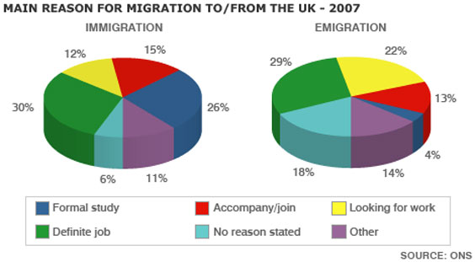

**Introduction** (Paraphrase the question, Write your own words what the graph(s) or tables showing, while paraphrasing you may add or change the information about type of the graph, title of the graph, scale of the graph and period of the graph.)

* The pie charts illustrate the percentage of main reasons why people entered and left the UK in 2007.
* The given pie charts illustrate the percentage of main reasons why people entered and left the UK in 2007.
* The migration factors to and from the UK in 2007 are depicted in the pie charts.
* The pie charts provide the information regarding the influencing factors of migration to and from the United Kingdom in 2007.

**Overview:** (In general terms, choose what main/interesting features are. You may choose highest/lowest factors, dramatic or exception changes, volatile changes, noticeable differences and similarities, increasing/decreasing or constant trend. Don't mention figures of the scales.)

* At first glance, it is clear that the definite job was the main reason for moving to and leaving the UK. However, a considerable difference was revealed in formal study factor between immigration and emigration.

**Body 1:**  (Explain the important features and other features in detail. Try to divide this information into two paragraphs.)

To begin with, a definitive job factor accounted for 30% of immigration to the UK, which was quite equivalent for emigration, at 29%. The second major factor influencing people to move to the UK was for formal study, with over a quarter (26%), surprisingly, only 4% of people left the country for the same reason. However, looking for work was the second-highest reason for emigration, accounting for 22%, while the proportion of people entering the UK was almost half that of emigrants.

**Body 2:**

Getting back to the details, the percentages for both immigration and emigration to join family were 15% and 13%, respectively, which were very close. Furthermore, unspecified reasons and other factors accounted for 18% and 14% of emigration, respectively, while these factors represented 6% and 11% with regard to immigration.

Complete Task:

The pie charts provide the information regarding the influencing factors of migration to and from the United Kingdom in 2007.

At first glance, it is clear that the definite job was the main reason for moving to and leaving the UK. However, a considerable difference was revealed in formal study factor between immigration and emigration.

To begin with, a definitive job factor accounted for 30% of immigration to the UK, which was quite equivalent for emigration, at 29%. The second major factor influencing people to move to the UK was for formal study, with over a quarter (26%), surprisingly, only 4% of people left the country for the same reason. However, looking for work was the second-highest reason for emigration, accounting for 22%, while the proportion of people entering the UK was almost half that of emigrants.

Getting back to the details, the percentages for both immigration and emigration to join family were 15% and 13%, respectively, which were very close. Furthermore, unspecified reasons and other factors accounted for 18% and 14% of emigration, respectively, while these factors represented 6% and 11% with regard to immigration.